GPH Simulation Exercise

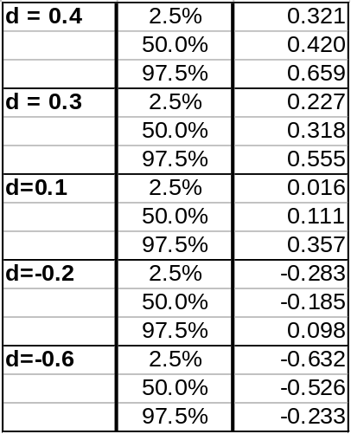
Table 1: Distribution of d-parameter of simulated fractionally integrated processes, determined though the GPH estimator
(n=1,000; Burn-In = 1,000; Simulations = 1,000; ARIMA(0,d,0))

Fractionally integrated processes of sample sizes 1000 were generated using fracdiff.sim from the ARIMA(0,d,0) distribution. The different d values are indicated in Table 1. The GPH estimator was used to estimate the fractionally integrated parameter d from the simulated data. Simulations of 1000 were used to construct the empirical quantiles above, with the purpose of understanding the accuracy of the GPH estimator.

Normality Test Accuracy

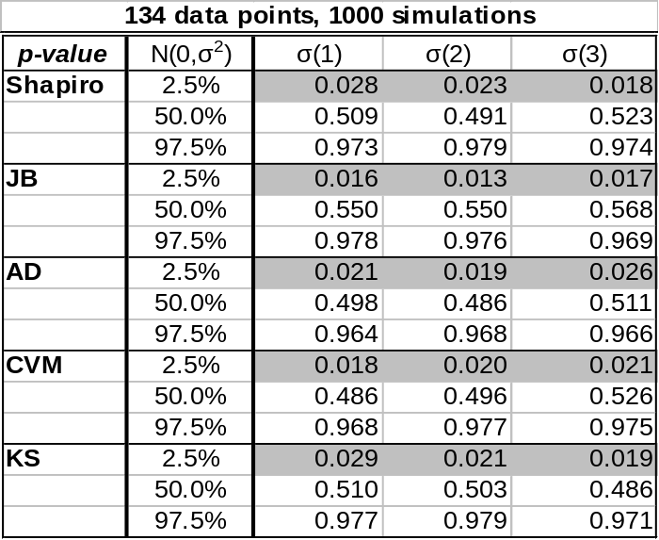
Table 2: Normality test p-values for simulated data, 134 data points
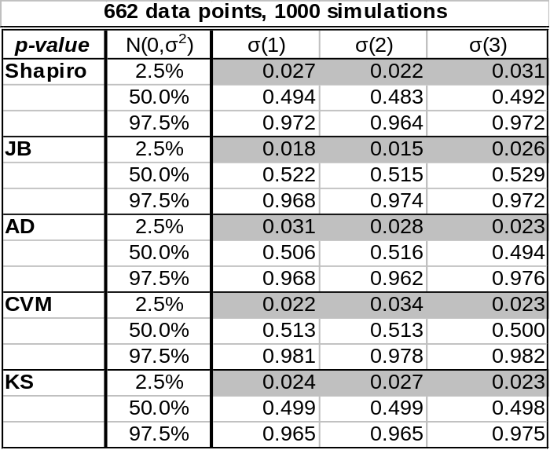
Table 3: Normality test p-values for simulated data, 662 data points

Data was simulated from a normal distribution, of both samples sizes 134 and 662, in Table 2 and 3, respectively. Normality tests were applied to the simulated data and the p-values were recorded. The simulation was repeated 1,000 times and the empirical quantiles of the p-values were recorded.

